**Nithin Das, CWID: 10422784, Date: 10/10/19 Assignment W&A 4th Edition, Ch 4, Q 4, Page 144**

I pledge on my honor that I have not given or received any unauthorized assistance on this

assignment/examination. I further pledge that I have not copied any material from a book, article,

the Internet or any other source except where I have expressly cited the source.

Signature: NITHIN DAS

Date: 10/10/2019

**Management Overview**

* **Problem Statement**

To develop a model that relates the number of ads on various television shows to the exposures to various viewer groups and use Solver to find the minimum cost advertising strategy that meets minimum exposure and maximum ads to be purchased constraints.

* **Data Sources**

Costs per ad, exposure for different age groups for different shows and minimum required exposures

* **Model Approach**
* Enter the input data in the spreadsheet.
* Create the ‘*Number ads purchased’* by entering random values initially for all the shows.
* Calculate ‘Actual Exposures’ for each age groups by using SUMPRODUCT of ‘*Number ads purchased’* and Exposure to respective age group.
* Use Solver to add ‘*Total Cost*’ as objective, constraints on ‘*Actual Exposures*’ and ‘*Maximum ads per show’*
* Use SolverTable to perform Sensitivity Analysis by creating a one way table between ‘*Maximum ads per show’ and ‘Total Costs’*
* **Solution & Sensitivity Analysis**

Results:

The minimized cost of reducing the pollution is $1894.

Sensitivity Analysis

The sensitivity analysis were performed on ‘*Total Costs*’ and ‘*Maximum ads that can be purchased per show*’ by setting minimum value of Input values to 2 and maximum value to 20 with an increment of 2 units. The analysis shows that, for input values less than 6, the solution is not feasible. However, the constraint value of 6 ads/show results in the maximum Total Cost, which reduces gradually after increase in the maximum ads/show value.

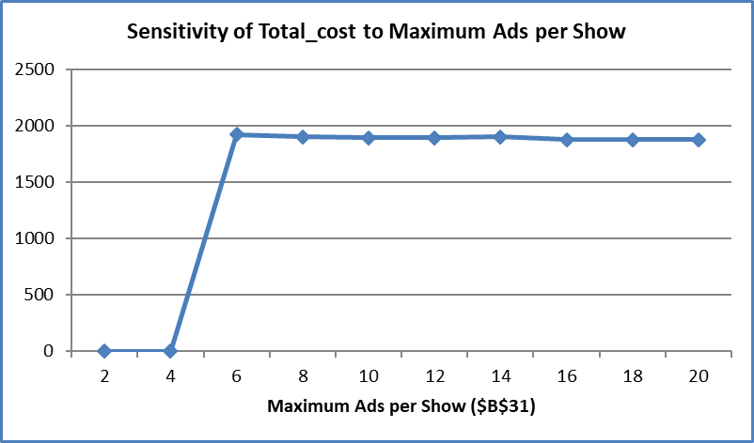

* **Recommendations**

By increasing the limit on Maximum ads that can be purchased per show, the company can achieve the minimized value on the Total Cost of purchases.